

2017 Kansas Book Festival Writing Contest

Contest opens January 11 and entries will be accepted through April 30.  
Winners will be notified by July 31 and recognized at the 2016 Kansas Book Festival on September 10.  
  
Theme: “Kansas Places”  
Describe a place that is unique to Kansas and explain its importance to the state of Kansas. A place could be a city, town, county, lake, river area, region (i.e., Flint Hills, northeast Kansas) or a building.   
Descriptions should include historical and/or present-day elements of the place.  
Open to Kansas students in grades 3-12.  
Winners will be divided by the four Congressional Districts.   
  
Criteria for Essays:  
3rd-5th grade essays should be no more than 750 words and original work.  
6th-8th grade essays should be no more than 1,000 words and original work.  
9th-12th grade essays should be no more than 1,500 words and original work.   
  
A strong essay will:

* Identify a place that is unique to Kansas (city, town, county, lake, river area, region (i.e., Flint Hills, northeast Kansas) or a building or attraction.
* Give historically and/or currently accurate details about the place.
* Explain how the place is important to Kansas.
* Reflect the importance of giving close attention to the conventions of spelling, grammar, capitalization, and punctuation as a way to effectively present one’s ideas to others.

Prizes:  
There will be one 1st place winner and one 2nd place winner in each of the grade level divisions per Congressional District.  
3rd-5th Grade: First place receives $100, Second place receives $50  
6th-8th Grade: First place receives $250, Second place receives $125  
9th-12th Grade: First place receives $500, Second place receives $250  
All winning essays will be compiled into a book and each winner will receive a copy.

Winners will be notified by July 31 via the e-mail address provided on the entry form and invited to attend the Kansas Book Festival on September 9 in Topeka to receive their prize and recognition. Should you be unable to attend, your prize will be mailed to you the week of September 11. Please make sure that you include contact information that will be valid at the end of the current school year.  
  
Essays must be submitted in Word Document Format (if e-mailed) ***and submitted with a registration form.*** (You are allowed to create a cover page for your entry that includes all of the categories listed in the registration form below without actually using the official form.)

Entries may be submitted via e-mail to [ksbookfestival@gmail.com](mailto:ksbookfestival@gmail.com) or by mail to:  
Topeka Community Foundation  
Attn: Kansas Book Festival  
5431 SW 29th St., Suite 300  
Topeka, KS 66614  
  
For questions, please call Rebecca at 785-271-3384 or e-mail [ksbookfestival@gmail.com](mailto:ksbookfestival@gmail.com).



2016 Kansas Book Festival Writing Contest

Name:  
  
Home Mailing Address:  
  
Congressional District (see attached map):  
  
Email address:  
  
Phone number:  
  
School name:  
  
School address:  
  
School phone number:  
  
Grade:  
  
Teacher:



2016 Kansas Book Festival Writing Contest  
  
Congressional District Map

[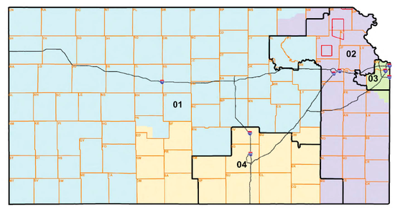](http://www.wrhammons.com/ks-elected-officials.htm)